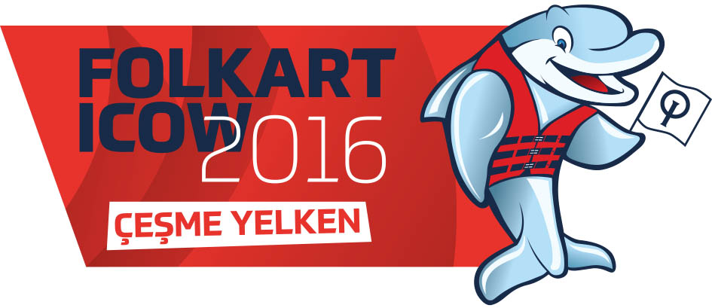
ICOW – FOLKART “INTERNATIONAL CESME OPTI WEEK 2016”
26 November – 1 December 2016
NOTICE OF RACE
1. Venue
Çeşme Sailing Club, Yildizburnu, Çeşme, Izmir/TURKEY
The event is organized by Çeşme Sailing Club.
2. General
The Sailing Instructions will be published at latest one week before the event on the website www.cesmeoptiweek.org and can be downloaded in PDF. They will not be handed over at the registration.
3. Rules
The regatta will be governed by the rules as defined in The Racing Rules of Sailing (RRS 2013 – 2016).
Rule 61.1 “Informing the Protestee” is changed as follows:
Add to rule 61.1(a) “The protesting boat shall inform the Race Committee of the boat/s being protested at the finishing line immediately after finishing.
Rule 40 and the preamble to Part 4 are changed as follows:
The first sentence of rule 40 is deleted and replaced by: “Each competitor shall wear a personal flotation device (PFD) according to class rule 4.2 (a), properly secured at all times while on the water except when temporarily adding or removing clothing.”
Add to the preamble of Part 4, after ‘racing’: “, except rule 40 as amended by instruction 1.4.1″
Rule changes will appear in full in the sailing instructions. The sailing instructions may also change other racing rules.
If there is a conflict between languages the English text will take precedence.
4. Advertising
Boats may be required to display advertising supplied by the organizing committee.

5. Entry
The regatta is open to all nations. Competitors must be born in 2001 and after.
Entries shall be made by submitting the online registration forms at
http://www.cesmeoptiweek.org/en/race-management/online-registration
Deadline for the entries is 21 October 2016. Late entries will not be given free accommodation and free charter boat.
6.Entry Fee
The entry fee is EUR 50. - per boat to be paid at the registration desk.
7. Eligibility
Optimist entries will be limited with 320 boats.
8. Registration and Sailing Instructions
Each competitor must be registered online at http://www.cesmeoptiweek.org/en/race-management/online-registration
Deadline for online registration is 21 October 2016
The Race Office will be open for registration on 19 Nov 2016 at 09:00h
Sailing Instructors will be displayed at least one week before registration on www.cesmeoptiweek.org

9. Schedule
26 Nov. Saturday
09:30 – 19:00 Registration
12:00 Team leaders and/or coaches meeting
13:00 Practice race
17:00 Opening Ceremony
27 Nov. Sunday (RACE DAY 1)
10:00 Team leaders and/or coaches meeting
12:00 Races

28 Nov. Monday (RACE DAY 2)
09:30 Team leaders and/or coaches meeting
11:00 Races
29 Nov. Tuesday (RACE DAY 3)
09:30 Team leaders and/or coaches meeting
11:00 Races

30 Nov. Wednesday (RACE DAY 4)
09:30 Team leaders and/or coaches meeting
11:00 Races
01 Dec. Thursday (RACE DAY 5)
09:30 Team leaders and/or coaches meeting
11:00 Races
15:30 Last warning signal
18:00 Price giving and closing ceremony

10. Prizes
First 10 competitors Overall – 1th Optimist dinghy – 2th Optimist sail – 3th Optimist parts
First 3 competitors Junior (Born 2004 or later) – 1th Optimist sail -2th Optimist parts -3th Optimist parts
First 3 competitors Girls – 1th Optimist sail -2th Optimist parts -3th Optimist parts
Presents by lottery at closing ceremony (sail, clothing , optimist parts ,etc.)
11. Charter Boats
The Organization Committee will provide free charter boats for 3 competitors from each club from visiting countries. ( It is limited with 9 boats for the same country).
If any team will need more than 3 boats, please contact the organization committee for extra charter boats (coach@cesmeyelken.org). Charter fee will be 50 euros per day.
Competitors shall not modify the boats or cause them to be modified in any way except that
• A compass may be tied or taped to the hull or spars;
• Wind indicators, including yarn or thread, may be tied or taped anywhere on the boat;
• Hulls, dagger boards and rudders may be cleaned, but only with water;
* Adhesive tape may be used anywhere above the water line; and
• All fittings or equipment designed to be adjusted may be adjusted, provided that the Class Rules are complied with.
Competitors may use their own foils, spars, fittings and running rigging.
Charter boats will be provided with airbag, racing spars, racing foils, padded toe straps, trolley.
Sail, 2 bailers, mainsheets and blocks, bowline, vang, outhull, sprit hall yard, and paddles will NOT be provided.
In addition to the charter fee a damage deposit of 150€ will be charged cash at the registration to be paid back at the end of the event.
Failure of the charter equipment shall not be subject to request for re-dress. This changes rule 62.1(a).
12. Accommodation
The organization will provide free accommodation for foreign teams only. It is limited with ‘’3 sailors and 1 team leader or coach’’ for each team. The accommodation dates are 19-25 November 2016. (6 nights)
Free accommodation will be given to the three clubs who applies first from the same country.
Deadlines for the entries 21 October 2016 . Late entries will not be given free accommodation.
If there is any additional sailors and/or coaches on your team for accommodation the fee will be 20€ per day/per person.
All free and paid accommodation will cover BB(bad and breakfeast) only.
Lunch boxes will be provided for sailors and coaches.
13. Support Boats
There will be a limited number of coach boats (RIB ) to be chartered.
Charter fee is 125€ per day
Reservation for coach boats must be done before 21 October 2016
14. International Jury
An International Jury will be constituted in accordance with RRS Appendix N. The decision of the Jury is not subject to appeal as provided in RRS.70.5.
15. Transportation
Local transportation will be provided by the organization from and to the International Adnan Menderes Airport. Airport to Venue aprox. 1 hour driving
Transportation fee will be 20€ per person (ONE WAY). Reservation for transportation must be done before 21 October 2016
16. Disclaimer of Liability
Competitors participate in the Championship entirely at their own risk and responsibility. See
rule 4, Decision to Race.
The Organization Authority and any other party involved in the organization of the Championship will accept no liability whatsoever for any injury, damage, loss or claim, whether personal or material, incurred by or inflicted to competitors before, during or after the Championship.
All competitors and support staff will be required to execute liability waiver.
17. Insurance
Each participating boat shall be insured with valid third-party liability insurance with a minimum cover of € 1,000,000.per event or the equivalent.
18. National Flag
Each team is requested to bring their own National Flag (100 x 150 cm).
19. Social events
Events to be announced www.cesmeoptiweek.org

The address of the venue;
Cesme Sailing Club, 5253 sok. No: 6/A, Yildizburnu mevkii, near Sheraton Hotel Çeşme.
https://goo.gl/maps/846SG5XggxP2

Registration Form : http://www.cesmeoptiweek.org/en/race-management/online-registration
Contact information:
Cesme Sailing Club
Pelin Yağlı Phone: +90 530 876 7004 coach@cesmeyelken.org
Emrah Sürmen Phone: +90 532 274 58 64 coach@cesmeyelken.org

